**Kongragate game research**

Game name: Impact Point

Pic of game: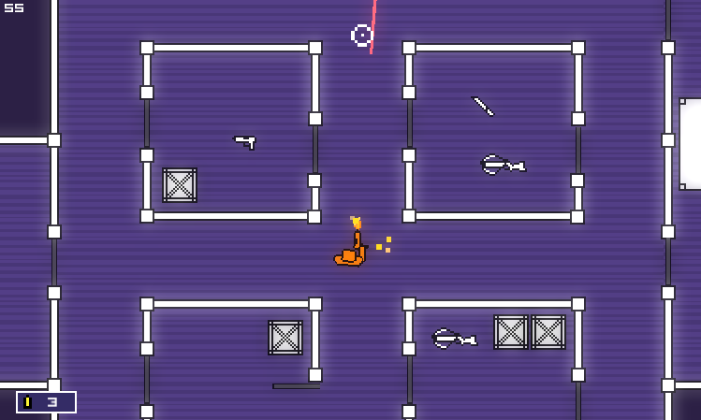

Key points: you can see where the bullets go. Multiplayer only

notes: players found the ability to see where the bullets are going is a cool feature but found the normal shooting boring

Game name: neon wars

Pic of game: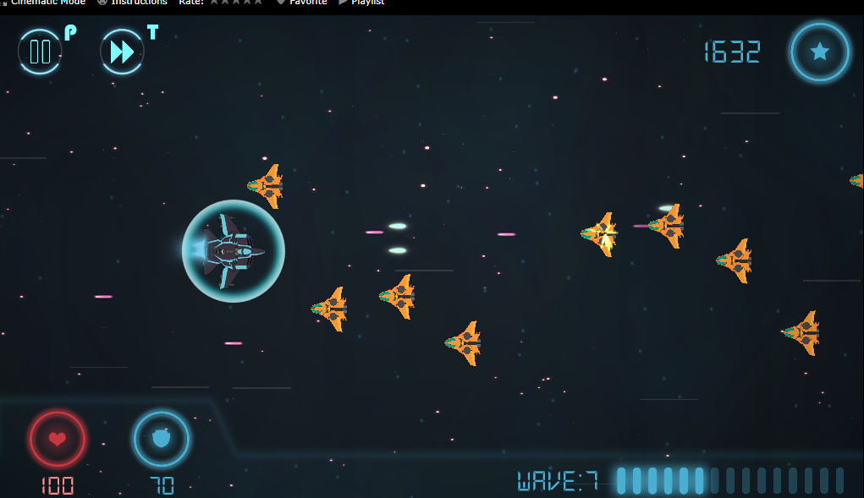

Key points: shooter where you upgrade your ship over time to get further in the game starting from the beginning each time you die

notes: players enjoyed the upgrades and customisation but did not enjoy having to start again each time they died.

Game name: Frantic 3

Pic of game: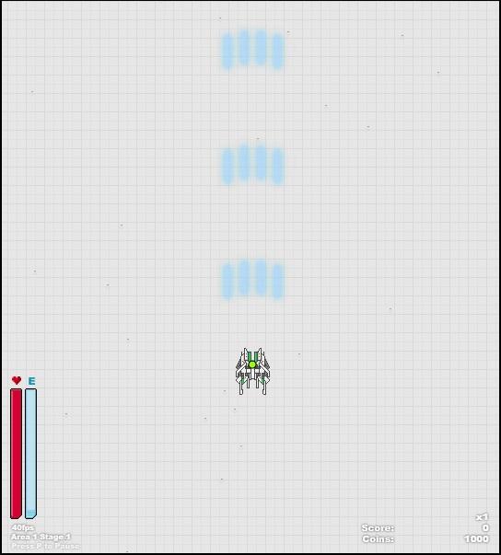

Key points: upgrades and power ups and bullet hell

notes: players think that having too many upgrades and power ups make the game too easy and the upgrade system too confusing

Game name: death-vs-monstars

Pic of game: 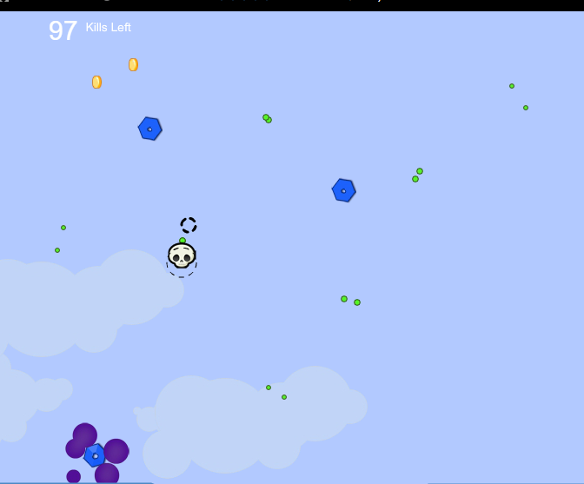

Key points: bullet hell

notes: some players thought too much was going on onscreen and that it was main the game confusing to play